|  |
| --- |
| [Void] |
| <SLO Wayfinding>  Statement of Work |
| [Student Life Office] |
|  |
| **Chonjou Chiang**  **Castiel Li**  **Ron Tran**  **Quincy Lam** |
|  |

**Please note - this is a document template, only. All of the text in *blue italics* is for explanatory purposes and must be overwritten or deleted (along with this note) when you create your own version of this document.**

**It is expected that the completed document will be *at least* 10 pages, including diagrams.**

|  |
| --- |
|  |

**Table of Contents**

1. Document Version 3

2. Team Contact Information 3

3. Description 3

4. Proposed Solution 3

5. Stakeholders and Users 3

6. Proposed Technology 3

7. Assumptions 3

7.1. Non-Technical Assumptions 4

7.2. Technical Assumptions 4

8. Project Goals, Tasks, Features 4

9. Deliverables 4

10. Out of Scope 4

11. Existing System 5

12. Diagrams 5

12.1. Client Diagrams 5

12.2. Team Diagrams 5

13. High-Level Schedule 5

14. High-Level Work Breakdown 5

15. Risks and Issues 5

## ***Document Version***

|  |  |  |  |
| --- | --- | --- | --- |
| **Version** | **Description** | **Date** | **Author(s)** |
| **1** | *Created* | *23/09/2017* | *Chonjou Chiang*  Castiel Li  Ron Tran |

## ***Team Contact Information****.*

TEAM 25

Supervisor: Donna Turner

|  |  |  |
| --- | --- | --- |
| Member Name | Email address | Phone |
| Castiel Li | castiel.andrew@gmail.com |  |
| Quincy Lam | [quincylam@hotmail.com](mailto:quincylam@hotmail.com) | 604-319-8830 |
| Nate Chiang | [chonjou@gmail.com](mailto:chonjou@gmail.com) | 604-704-5442 |
| Ron Tran | [ronnotran97@gmail.com](mailto:ronnotran97@gmail.com) | 604-441-3645 |
| Donna Turner (Supervisor) | dturner80@bcit.ca |  |

## ***Description***

* A web application that show students information about all BCIT Student Services. In the meeting, we were told that many BCIT students do not know much about these services, so they rarely come and use any of these services although they are all free.
* The BCIT Student Life Office (SLO) wants to make this web application in order to raise student’s awareness about BCIT Student Services. Also, with part-time students and new students, who cannot make it on orientation day, they can use this app to get information about all of services that are available in BCIT.

## ***Proposed Solution***

We decided to create a single page web application to solve the problem. We will use the category icons that provided by SLO as our main page. When a user clicks on them, all the services that are part of the category will be displayed. When the user clicks on one of those services, it will display some basic information(brief description, operation time, location, website and a student video that provided by SLO office. There will be also a search bar where students can search for the service they were looking for. Our intent is to give student a shortcut/gateway to access the services they need, therefore, we will contain our page within three clicks.

## ***Stakeholders***

* BCIT Student Life Office(SLO)
  + SLO is our client for this project, they need a web application that is easy to use, cover all type of students and provide information of all the service BCIT have for their students.
  + Contact Info: student_life@bcit.ca
* BCIT Students
  + The BCIT students will be our primary users. This includes all the students, part-time, full-time, distance etc. They need a easier and faster way to find all the service they can access from BCIT.
* Potential Students
  + Some potentials students may want to know they service they can get if they chose to study at BCIT.

## ***Proposed Technology***

For this project, we are decided to use React as our main scripting language. We will also use CSS, HTML, and one of the database. We have not yet decided on what database we will be using at this time. React is the best fit for our single page application, it loads everything at once and displays information base on the filter we provided. We will be able to speed up the loading time for the application by a significant amount of time. Since there might be many pics being implement in the future and this will be a handly informational website, the fast loading speed will help us improve user experiences.

## ***Assumptions***

## ***Non-Technical Assumptions***

1. The client will provide us with the information to display
2. The client will provide us with videos to create a student to student voice

## ***Technical Assumptions***

1. The student team will determine the back-end and front-end technologies;
2. Project web site will use React.js , CSS, HTML.
3. The team will be in charge of the design and development of the GUI

## ***Requirements***

* Features
  + Search Bar
  + Video for each service if provided by SLO
  + Eight category icon which is clickable and will expend into all service under that category
  + Mobile friendly
  + Fast loading and responding time
  + Access all the information within three click from the main page
  + Desktop friendly
  + Chrome and Firefox browser friendly

This application will be fully functional by the end of the project, it means we will implement everything SLO provided up and have it ready to launch. We will finish the design, implementation, and testing stage. We will not be able to launch the application because we do not have the access to BCIT IT service. The client is in charge of contacting the IT service and host our website.

## ***Deliverables***

|  |  |
| --- | --- |
| **Deliverable** | **Description** |
| UI/UX design | The team will provide the client with a design that will is consisted of three panels on desktop and a singular one in mobile. |
| Front end of the application | The team will also be in charge of the development of the UI/UX design. |
| Responsiveness on the latest device on Android and iOS | The team will focus their efforts on two devices one for each operating system. The team will not try to achieve responsiveness on every device and every browser, only the most common ones. |
| Back end of the application | The team will take part in the back end if needed. |

## ***Out of Scope***

* After having two meetings with Student Life Office (SLO), we realized that there are some features that we might not be able to do:

+, Plug our web application into D2L

+, Our app might not be fully responsiveness

## ***Existing System***

The existing system is difficult to navigate to find specific information about the student services. This new web app will allow students to be introduced at all the services available to them at BCIT.

## ***Diagrams***

## ***Client Diagrams***

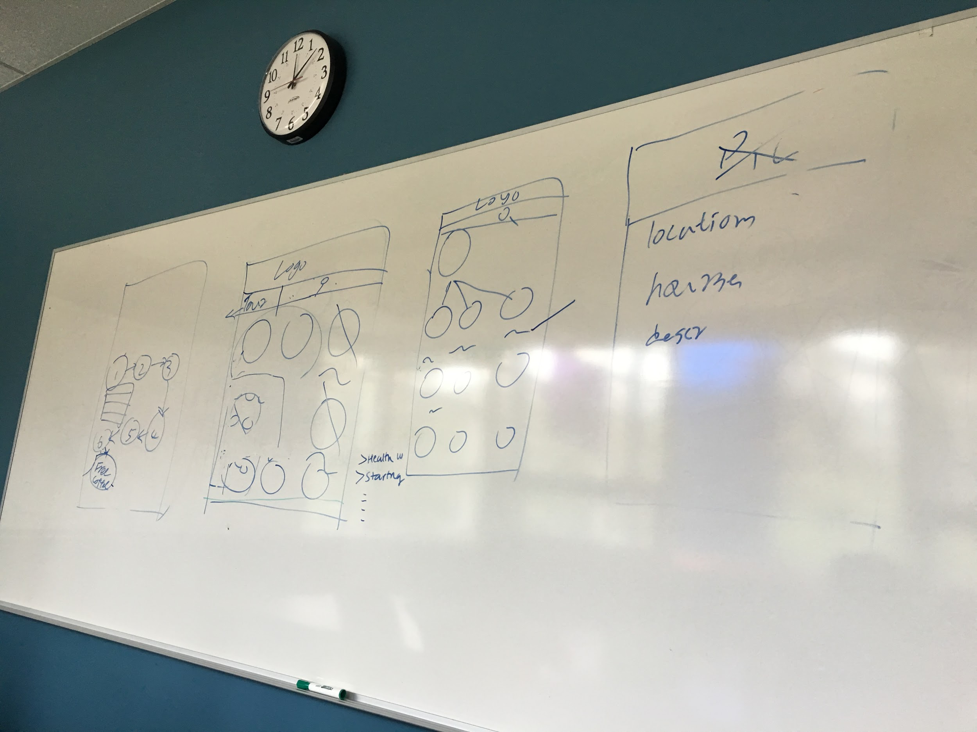

This diagram was produced with the help of the client to portray the basic structure of the final product.

## ***Team Diagrams***

We have not yet created any diagrams during our team meeting. We spend most of our time to figure out the client requirement and we have worked with a client during client meeting which resulted of the diagram above.

## ***High-Level Schedule***

1. UI/UX design of the front end of the web application
2. Setting up of the React.js framework
3. Begin the coding of the front-end.
4. Once finished go over the front-end with the client and polish further via email and weekly meeting (Our client is on campus which makes the communication much easier for us)
5. Repeat steps 3 and 4 until all the requirements and the client is satisfied with the look of the application

## ***High-Level Work Breakdown Structure (WBS)***

|  |  |  |
| --- | --- | --- |
| **Owner** | **Description** | **Completion Date** |
| Nate Chiang | Decide Database will be used for the application | September 30, 2017 |
| Castiel Li | Develop prototype for client. | September 30, 2017 |
| Ron Tran | Study and learn ReactJS for project | September 30, 2017 |
| Quincy Lam | Study and learn ReactJS for project | September 30, 2017 |
| Castiel Li | In charge of setting up meeting | Ongoing |
| Castiel Li | In charge of document meet due dates | Ongoing |
| Quincy Lam | Take notes during meetings and complete meeting minutes | Weekly |
| Castiel Li | Set up git repo for the application | September 30, 2017 |
| Nate Chiang | Setup database and connect with the application | Oct7, 2017 |
| Team | Basic layout with place holders | Oct 7, 2017 |
| Ron Tran | Keep track of estimate time and actual time differ | Weekly, Ongoing |

## ***Risks and Issues***

|  |  |  |
| --- | --- | --- |
| **Risk or Issue Description** | **Potential Impact** | **Mitigation/Resolution Steps** |
| Developing features that is not what client needs | Large impact | Establish all requirements first before starting project |
| Cannot complete all the requirement in time | Large impact | Analyze all the features and determine if they are within our skill set |
| Unfamiliarity with new technologies | Medium impact | Get familiar with React.js as soon as possible |